Press Release

For Immediate Release

**Hong Kong Smart Design Awards 2025 Winners Announced**

**Four-Day Exhibition at the Hong Kong Gifts & Premium Fair**

**Connecting Hong Kong Designers with Local and Global Buyers**

**Co-operates with local recycling organizations, demonstrate environmental responsibility**

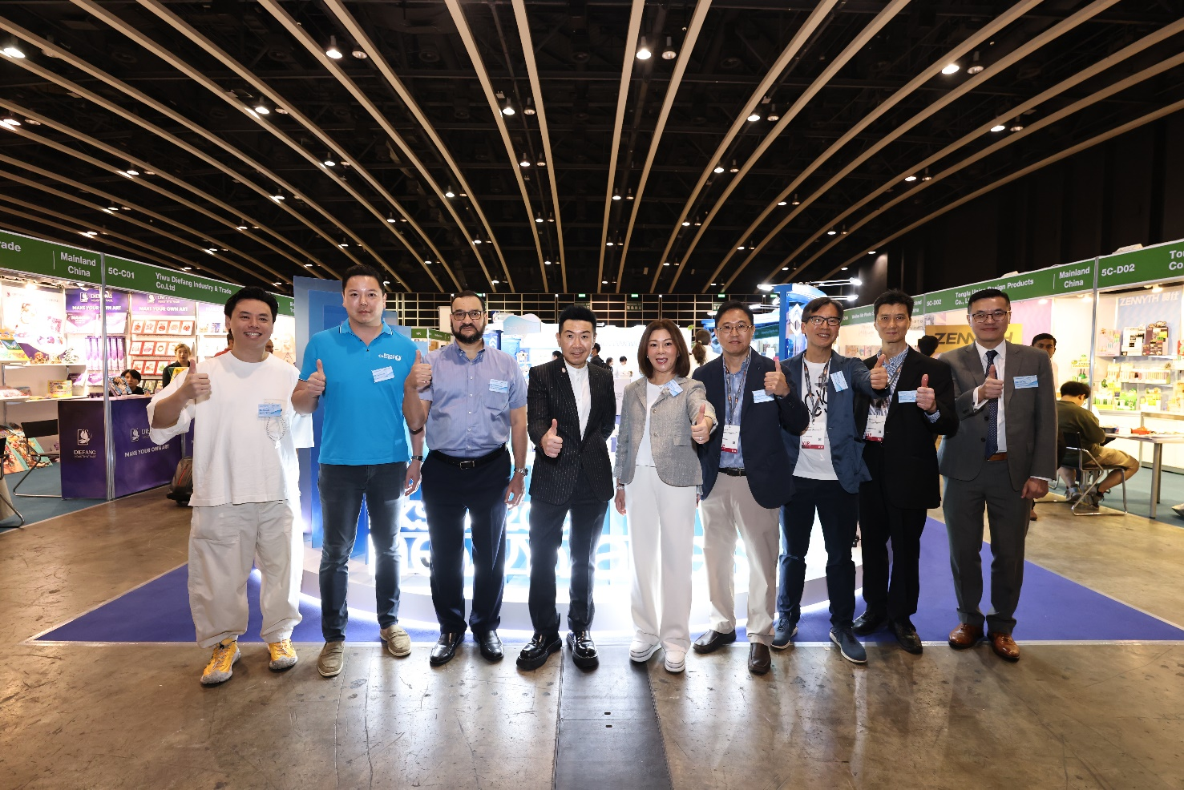High-resolution images: <https://drive.google.com/drive/folders/1bn2AvhfGtGMDKE_lba9Vsqqm-ts4ws-5?usp=sharing>

(Hong Kong, 27 April 2025) Organized by the **Hong Kong Exporters’ Association** (HKEA) and fully supported by the **Cultural and Creative Industries Development Agency** (CCIDA) of the HKSAR Government, the highly anticipated annual Hong Kong Smart Design Awards 2025 (HKSDA) officially announced its winners today. Selected award-winning works are showcased at the renowned Hong Kong Gifts & Premium Fair organized by the Hong Kong Trade Development Council (HKTDC). With the theme "NEW WAVES", this year’s Awards celebrate innovation, forward-thinking creativity, and distinctive designs. By embracing cutting-edge technology, reimagining user experiences, and exploring sustainable solutions, HKSDA provides a vital platform for designers to showcase their talents and forge new partnerships across industries.

The 2025 Awards selected 65 outstanding works after a rigorous review process. Not only do these award-winning designs highlight the exceptional creativity and professionalism of Hong Kong designers but also reflect the spirit of innovation and sustainability of the theme "NEW WAVES". Starting from today, these outstanding designs will be exhibited for four consecutive days at the Hong Kong Gifts & Premium Fair, offering designers valuable exposure to potential business opportunities in both local and international markets.

Since its inception in 2012, HKSDA has become a signature event for Hong Kong’s design community, attracting over 2,500participating companies and showcasing more than 5,000original designs to date. The award features two major categories: the Corporate Group and the Concept Group, split into three major categories: “Toys and Games”, “Gifts” and “Home and Houseware”; making a total of 15 sub-categories. This expanded scope ensures a broader representation of Hong Kong’s original designs. An official Awards Ceremony will be held at the Hong Kong Palace Museum on 16 May 2025, with further details to be announced in due course.

**NEW WAVES: Pioneering the Next Design Frontier**

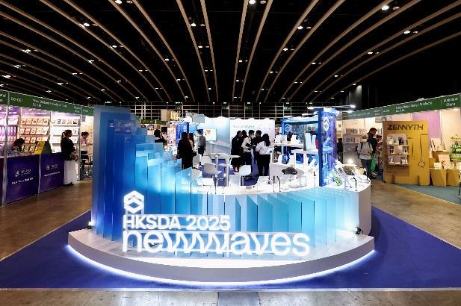The "NEW WAVES" theme encourages designers to break through the traditional framework and explore innovative and sustainable design solutions. The winning entries demonstrated Hong Kong designers' ability to balance innovation and practicality.

**Mr. Eric Sun, Chairman of The Hong Kong Exporters' Association**, remarked at the opening ceremony: “The winning entries of this year's HKSDA fully demonstrated Hong Kong designers' innovative thinking, professional strength, and sensitivity to market demands. It is hoped that the Hong Kong Smart Awards will bring Hong Kong's original designs to a bigger global stage, so that Hong Kong design represents not only creativity, but also high value-added and global recognition, further consolidating Hong Kong's position as a design hub in Asia and writing many more brilliant chapters for Hong Kong design. It is expected that designers will be able to connect with local and overseas buyers through the platform of Hong Kong Gifts & Premium Fair, so that they can bring their works to the market and add commercial value into their brands and designs.”

This year’s Smart Design Awards is also committed to promoting sustainability and minimizing the environmental impact of the exhibition. All showcase structures will be reused for local exhibitions, a standard practice to extend their lifespan. Additionally, the event has partnered with local recycling company Hong Kong Recycling Corporation Limited to further reduce exhibition waste. The company will collect over 90% of showcase structures after the event and issue an ISO certified recycling certificates, ensuring that resources are properly managed and reinforcing the awards' dedication to environmental responsibility.

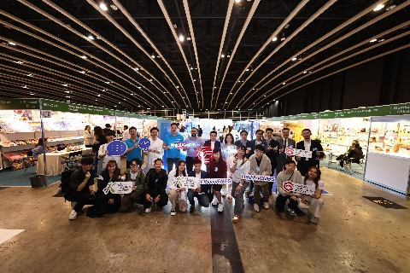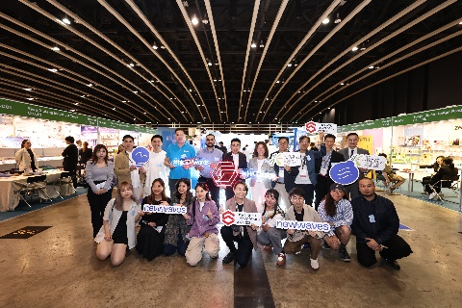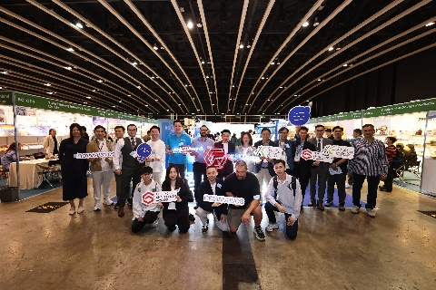

**Professional Judges Highly Appreciate the Entries' Unlimited Market Potential**

The judging panel of this year's HKSDA is composed of experts from the design, marketing, academic and export sectors, who selected the entries based on a number of criteria, including commerciality, innovation, functionality, design and environmental elements. As technology advances and social needs change, the role of design is shifting from mere aesthetic expression to a tool for problem solving.

The Hong Kong Smart Design Awards 2025 is not only a competition, but also a platform to promote design innovation and social progress. Through the theme ‘NEW WAVES’, the Awards encourage designers to respond to global challenges with innovative thinking and create more possibilities for future life.

This year's HKSDA professional jury is composed of ten experts from the fields of design, marketing, academia and industry, including (in no particular order): **Mr. Wong Kim Fung (Chairman of the Hong Kong Brand Toy Association), Mr. Kenneth Wong (Vice Chairman of the Hong Kong Toys Council), Ms. Makiko Tsumura (Director of the Japan Institute of Design Promotion), Ms. Noletta Chiu (Executive Director of Medialink Group Limited), Mr. Samson Ko (President of The Toy Manufacturers' Association of Hong Kong), Prof. Tong Huiming (Professor of Guangzhou Academy of Fine Arts), Dr Yin-Lun Chan (Head of the Department of Design and Architecture of Technological and Higher Education Institute of Hong Kong (THEi)), Mr. Alan Cheung (Chairman of the Federation of Hong Kong Industries - Group 31 (Design)), Mr. David Lo (Creative Director of LOMATTERS), Mr. Tommy Li (Creative Director of Tommy Li Design Workshop), Mr. Ricky Chan (Vice Chairman of the Federation of Hong Kong Industries - Group 31 (Design))**

After carefully examining and rating the entries, the professional judges have selected the Gold, Silver, Bronze and Merit Awards for the “Toys and Games”, “Gifts” and “Household and Homeware” in the “Company Category” and “Conceptual Category”. The judges have also selected the Green Award and the Student Award. The Gold, Silver, Bronze and Merit Awards in each category are attached. Refer to Annex for the list of the Gold Award entries in each category. The official winners list for Hong Kong Smart Design Awards 2025 is now available at: <https://www.sdawards.org.hk>

**Hong Kong Gifts & Premium Fair: Connecting Creativity with Business Opportunities**

As one of Asia’s largest gifts and premium exhibitions, the Hong Kong Gifts & Premium Fair offers an unrivaled platform for designers to engage with global buyers. This year’s Fair features a dedicated Smart Design Pavilion, exclusively showcasing HKSDA award-winning works. The exhibition also includes design forums and workshops, providing valuable insights into emerging design trends and market demands, opening new doors for collaboration and innovation.

**About Hong Kong Smart Design Awards**

Hong Kong Smart Design Awards (HKSDA) is organized by The Hong Kong Exporters' Association and supported by the Cultural and Creative Industries Development Agency (CCIDA) as the Lead Sponsor. HKSDA has been devoted to unveil the brilliance of Hong Kong original design to the world and encourage local manufacturers and exporters to reform business strategy in attaining “Design x Strategy x Technology = Smart Business” since 2012. Since its 14th edition, HKSDA has become an industrial signature event among local sectors including gifts, product design and procurement and has built renowned reputation for its quality among overseas buyers through a spectrum of local and overseas activities catering to both B2B and B2C, i.e. trade fairs to reach out buyers, roving exhibition in shopping malls and communities to raise public awareness of HKSDA. Over the years, HKSDA has expanded the product categories for entries from the original “Gifts” to include “Home & Houseware” (added in 2017) and “Toys & Baby” (added in 2020, later renamed to “Toys & Games”), hoping to nurture both creativity and commercial skills among designers, design students and up-and-coming talents so to boost their competitive edges in this ever-changing landscape, which in turn, benefits the manufacturing and export industries as well as the Hong Kong economy as a whole.

**About The Hong Kong Exporters' Association**

Founded in 1955, The Hong Kong Exporters’ Association (HKEA) is a non-profit making trade association registered under the Hong Kong Companies Ordinance as a company limited by guarantee. The HKEA is committed to creating new business opportunities and enhancing market value for Hong Kong exporters, aiming to position Hong Kong as a premier trading hub. The HKEA focuses on serving the industry and taking export trade as its core value, helping members expand their business by closely liaising with the government, initiating different projects, and organizing seminars, business gatherings, business delegation trips and exhibitions. The HKEA also disseminates the latest local and international trade information and provides online product display and search services for additional publicity, to further promote Hong Kong's export trade and enhance market competitiveness.

For more information, please go to The HKEA website: [www.exporters.org.hk](http://www.exporters.org.hk/)

**About Cultural and Creative Industries Development Agency**

The Cultural and Creative Industries Development Agency (CCIDA) established in June 2024, formerly known as Create Hong Kong (CreateHK), is a dedicated office set up by the Government of the Hong Kong Special Administrative Region under the Culture, Sports and Tourism Bureau to provide a one-stop service and support to the cultural and creative industries with a mission to foster a conducive environment in Hong Kong in order to facilitate the development of arts, culture and creative sectors as industries. Its strategic foci are nurturing talent and facilitating start-ups, exploring markets, promoting cross-sectoral and cross-genre collaboration, promoting the development of arts, culture and creative sectors as industries under the industry-oriented principle, promoting Hong Kong as Asia’s creative capital and fostering a creative atmosphere in the community to implement Hong Kong’s positioning as the East-meets-West centre for international cultural exchange under the National 14th Five-Year Plan.

CCIDA’s website: [www.ccidahk.gov.hk](http://www.ccidahk.gov.hk)

Disclaimer: The Government of the Hong Kong Special Administrative Region provides funding support to the project only, and does not otherwise take part in the project. Any opinions, findings, conclusions or recommendations expressed in these materials/events (or by members of the project team) are those of the project organizers only and do not reflect the views of the Government of the Hong Kong Special Administrative Region, the Culture, Sports and Tourism Bureau, the Cultural and Creative Industries Development Agency, the CreateSmart Initiative Secretariat or the CreateSmart Initiative Vetting Committee.

- THE END –

The press release is distributed by SimFusion Technology Ltd., for enquiries, please contact︰

Phoebe Chan Tel: 2341 6938 / 6396 0095 Email: [phoebe@simfusion.com.hk](mailto:phoebe@simfusion.com.hk)

Yuki Chan Tel: 2341 6177 / 6206 5233 Email: yuki.chan@simfusion.com.hk